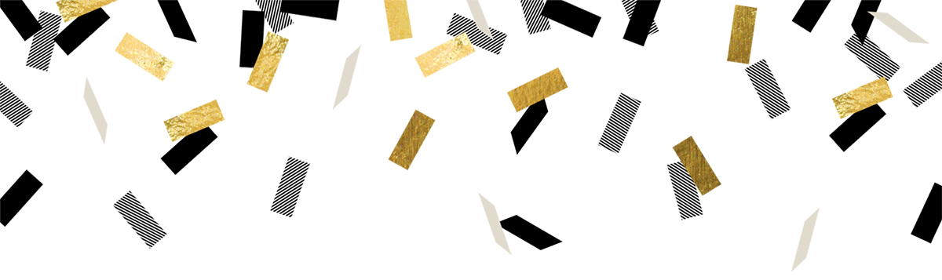
Congratulations, Everett Sail and Power Squadron
2023 BoatUS Civic Service Award Winner!

Your contributions and efforts were absolutely stellar and it was an honor to read your application and "see" you in action.

Exceptionally Well Done!

P/R/C Connie Shay
Squadron Support and Development

